Administrating remote system

Tasks

1.Use ssh to connect from your Linux system to a remote server (you can use a free-tier cloud VM or a local VM). After connecting, create a directory named 'music_downloads' in your home folder on the remote server.

SSH to Remote Server

Step 1: Check SSH Service

systemctl status sshd

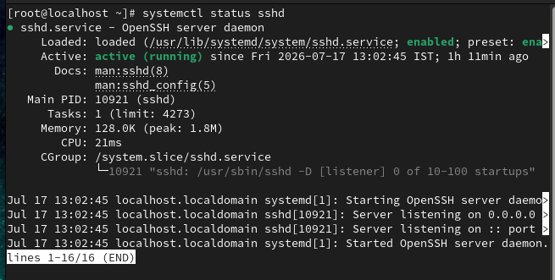

Step 2: Connect to Remote Server

ssh du@localhost

Type:

yes

Enter password.

Step 3: Create Directory

mkdir ~/music_downloads

Verify

ls

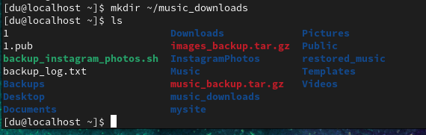

2.Transfer a file named 'playlist.txt' from your local machine to the remote server's 'music_downloads' directory using the scp command.<br><br><em><strong>Hint:</strong> Check the syntax for scp to specify both source and destination paths.</em>

Transfer File using SCP

Step 1: Create Sample File
On Local Machine

echo "My Playlist" > playlist.txt

Verify

ls

Step 2: Copy File

scp playlist.txt du@localhost:~/music_downloads/

Enter password.

Step 3: Verify
Login

ssh du@localhost

Check

ls ~/music_downloads

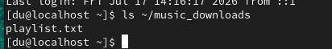
3.Set up passwordless SSH login from your local Linux system to the remote server by generating an SSH key pair and copying the public key to the remote server.<br><br><em><strong>Constraint:</strong> Do not use a passphrase for the key during this setup.</em>

Passwordless SSH
Switch to normal user

su - du

Generate key

ssh-keygen

Press Enter for everything.
Copy key

ssh-copy-id du@localhost

or

ssh-copy-id du@192.168.75.130

Enter password once.

Test

ssh du@localhost

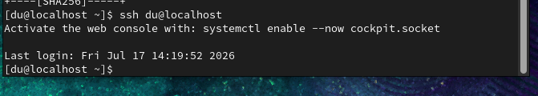

4.Simulate a Zomato-style admin task: Write a bash script on your local machine that uses ssh to remotely restart the 'nginx' service on the remote server and then checks its status. Save your script as 'remote_nginx_check.sh'.

Bash Script
Create file

vi remote_nginx_check.sh

Paste

#!/bin/bash

ssh -t du@localhost << EOF
su -
systemctl restart httpd
systemctl status httpd --no-pager
exit
EOF

Save

Esc
:wq

Permission

chmod +x remote_nginx_check.sh

Run

./remote_nginx_check.sh

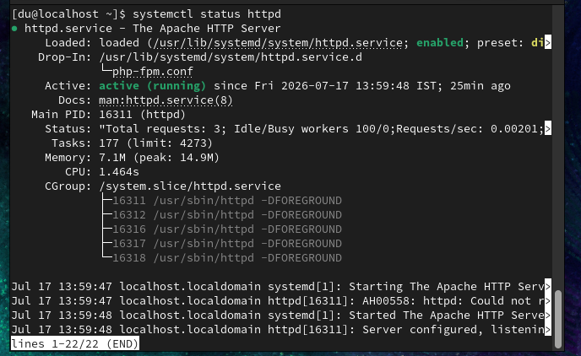
5.Find and fix the error in this ssh command: ssh user@192.168.1.100:/home/user/music_downloads<br><br><em><strong>Hint:</strong> Review the correct syntax for connecting to a remote server with ssh.</em>

Fix SSH Command
Incorrect command:

ssh user@192.168.231.128:/home/user/music_downloads

Correct command:

ssh user@192.168.231.128

After login:

cd /home/user/music_downloads

Or in one command:

ssh user@192.168.231.128 "cd /home/user/music_downloads && pwd"

Explanation
The ssh command connects only to a host. You cannot append a remote directory after the hostname. To access a directory, log in first and then use cd, or execute the directory change as part of a remote command.

